Steps To Run This Project

1. Create a New Folder Where to Clone the Github Repository
2. In the created folder, clone the Repository from URL: <https://github.com/ivan-verges/CafeTownSend.git>

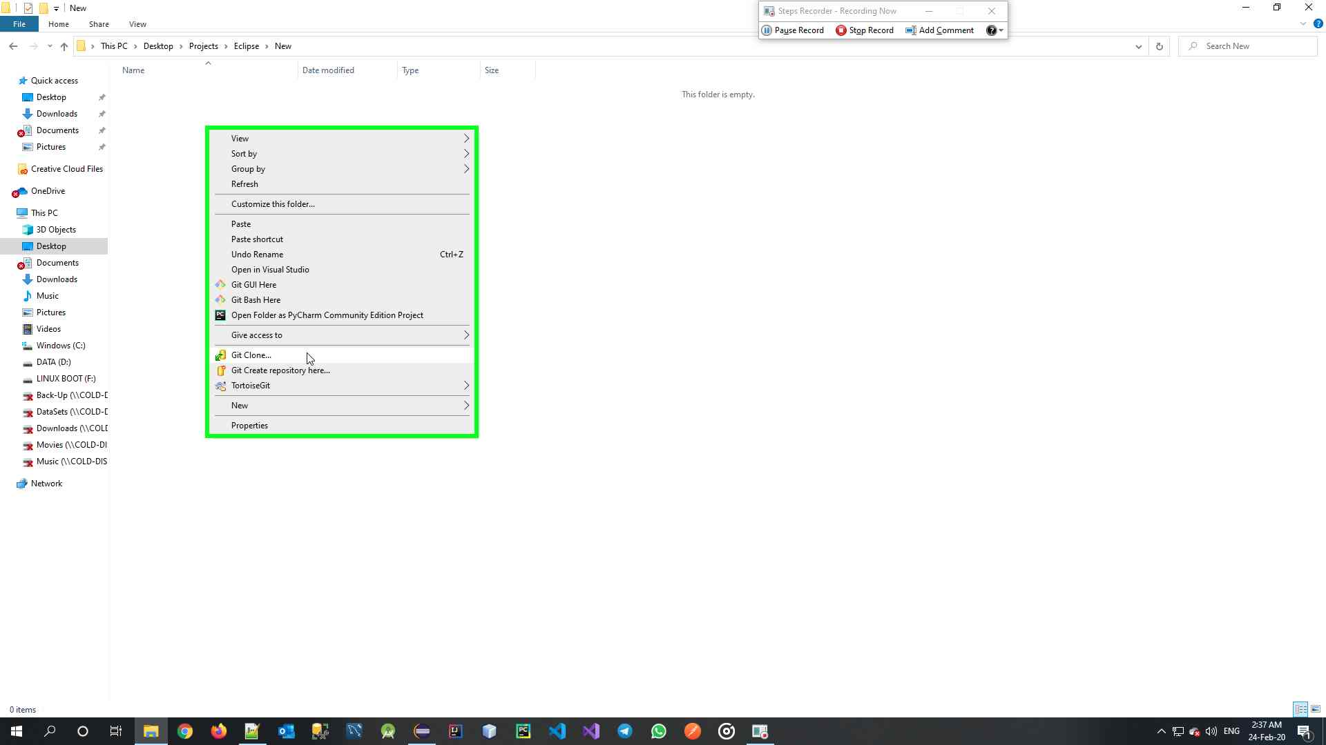

I’ll clone the repo using Tortoise Git, but you could use any Git tool, including the Bash Console

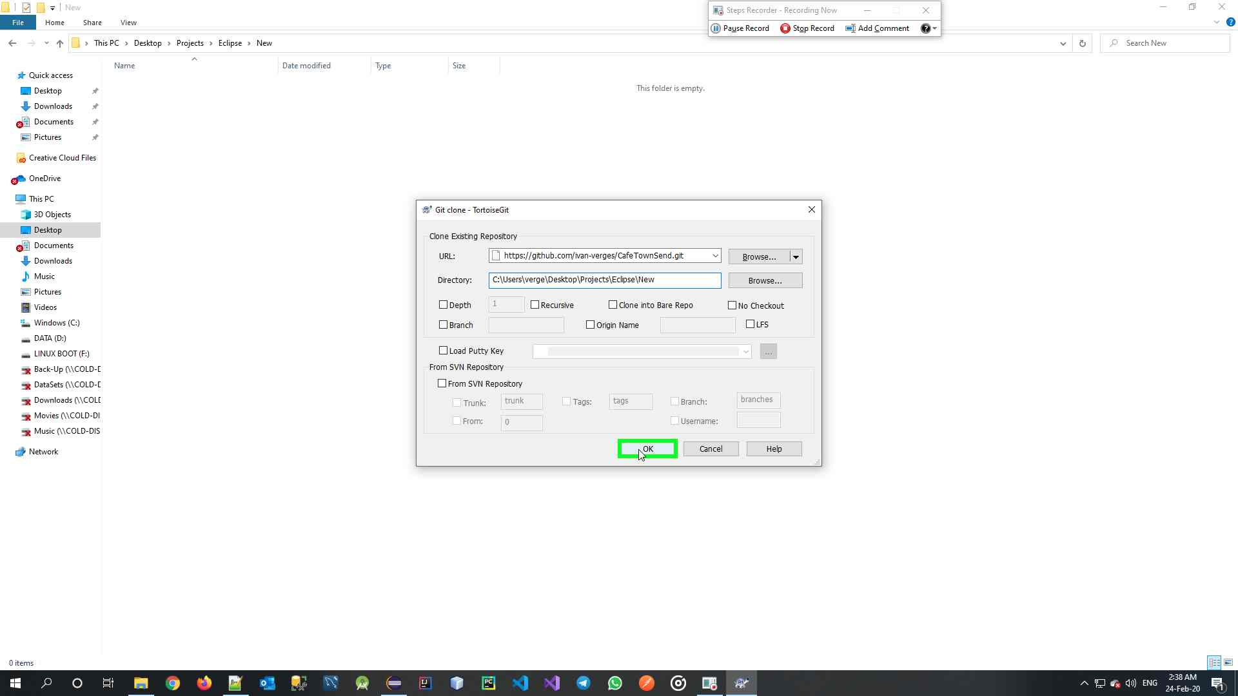

Insert the URL and the Local Path, then click OK

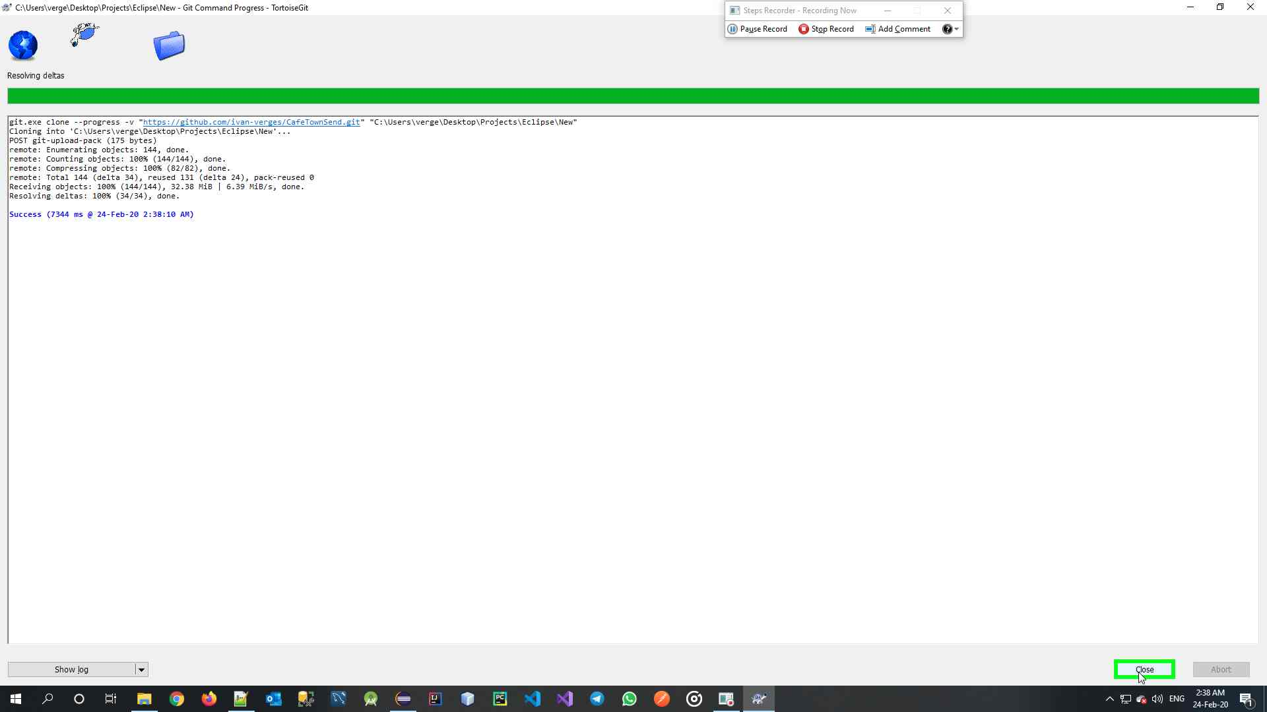

After cloning finishes, click Close

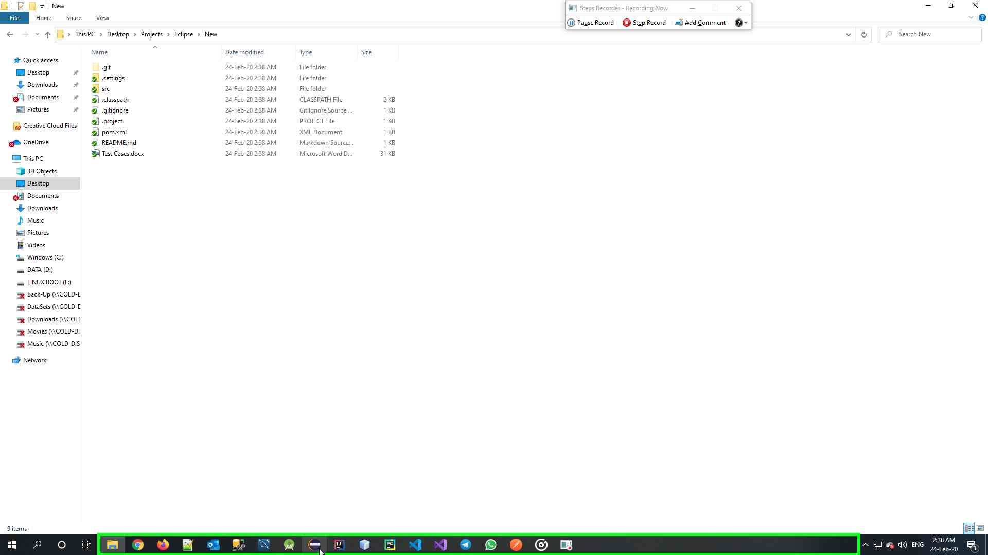

Verify cloned files on folder

1. Open Eclipse and Import the cloned project

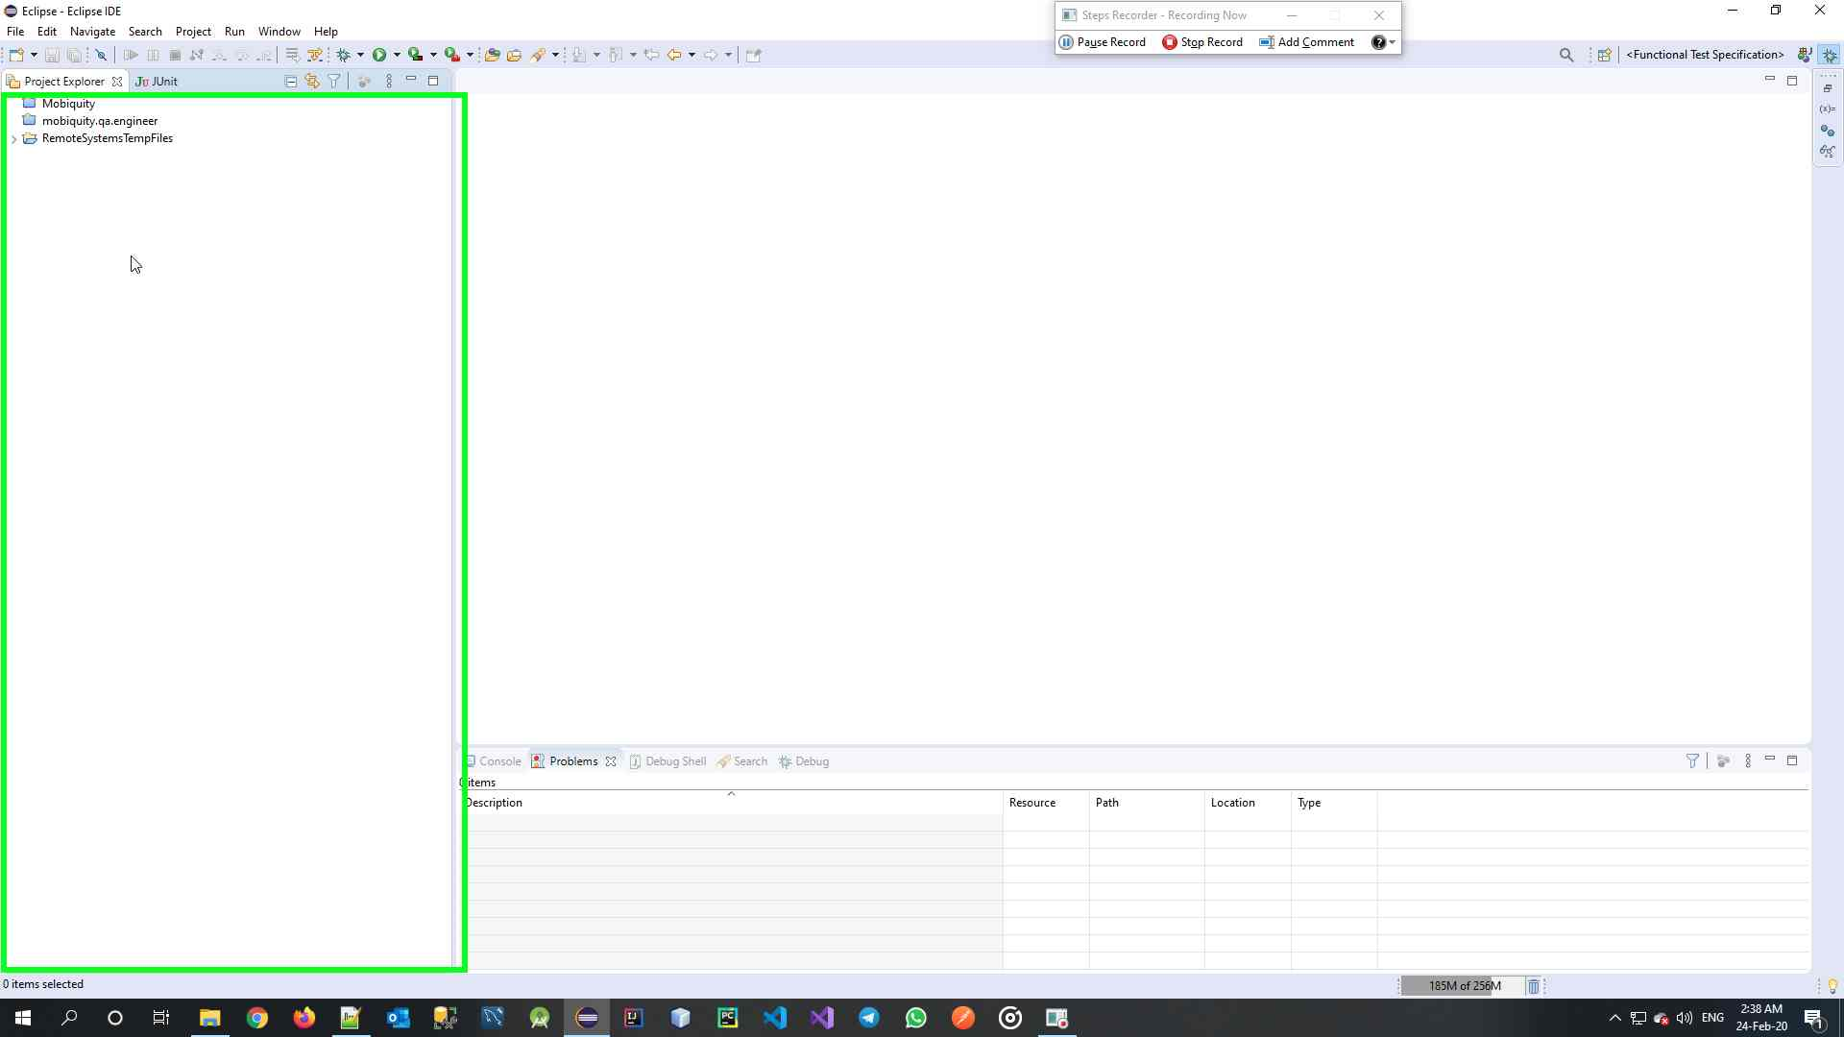

On the Project Explorer in Eclipse, perform a Right Click

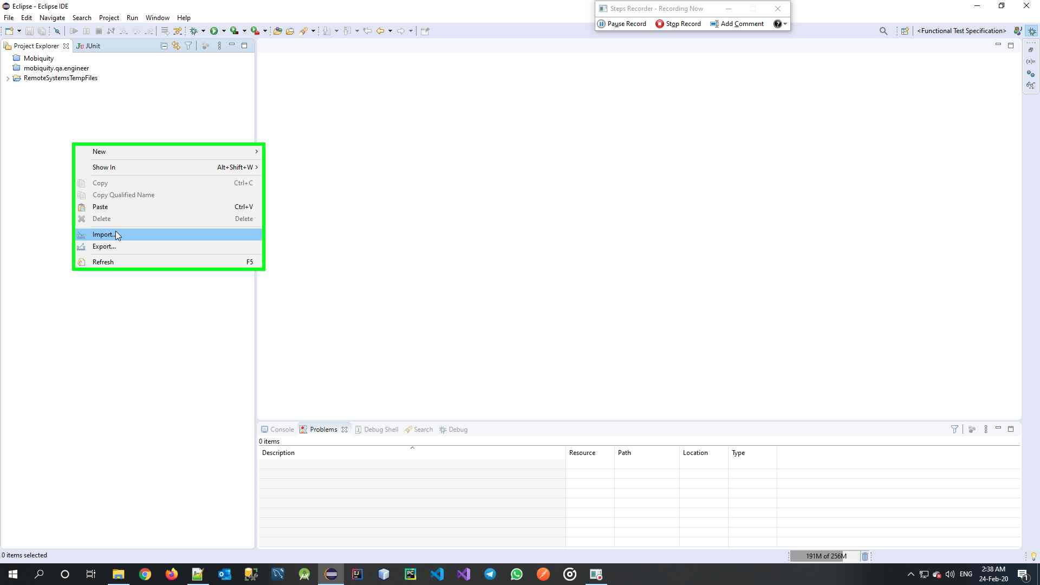

Select Import

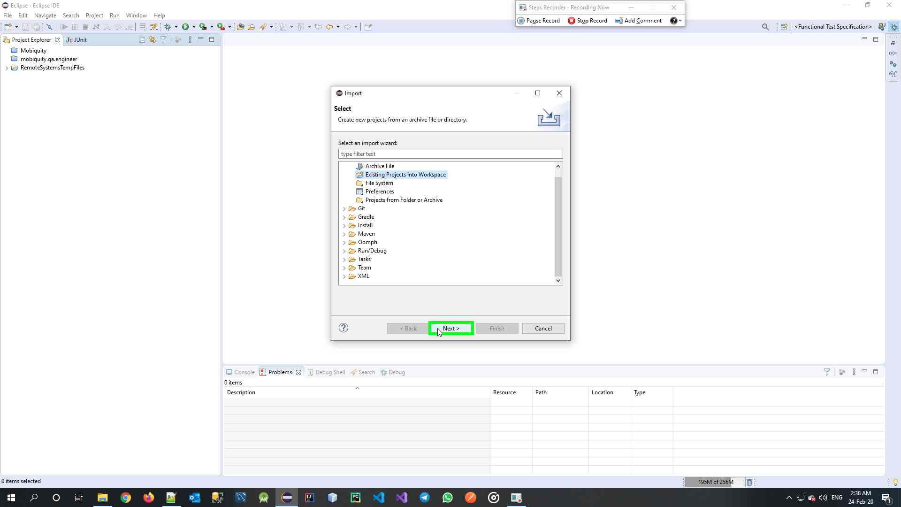

Select Existing Project into Workspace and click Next

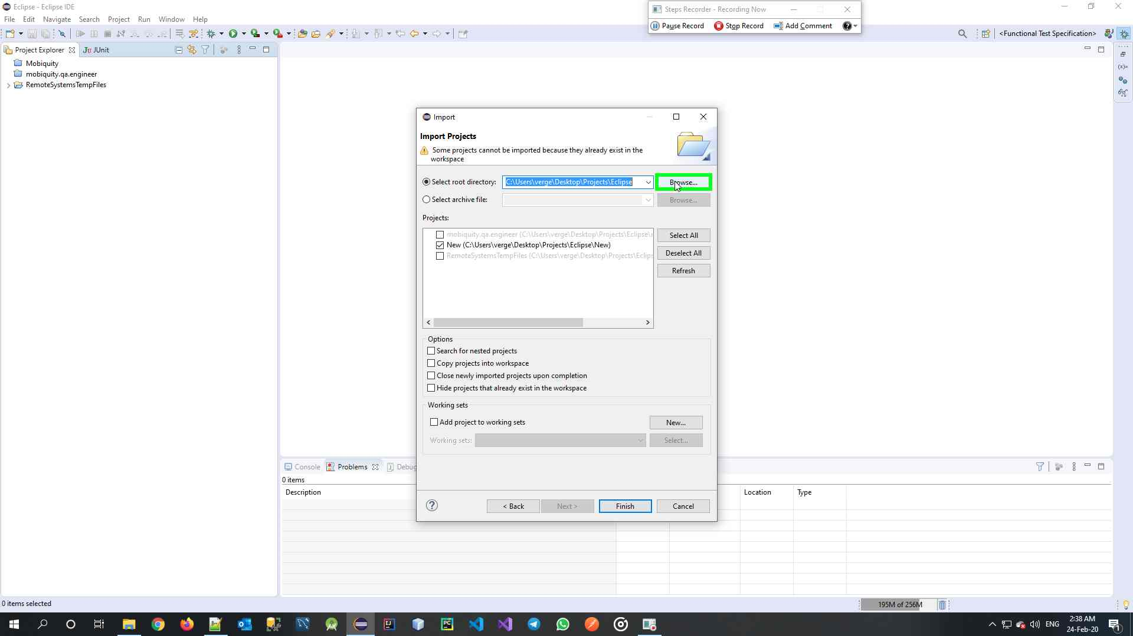

Click Browse

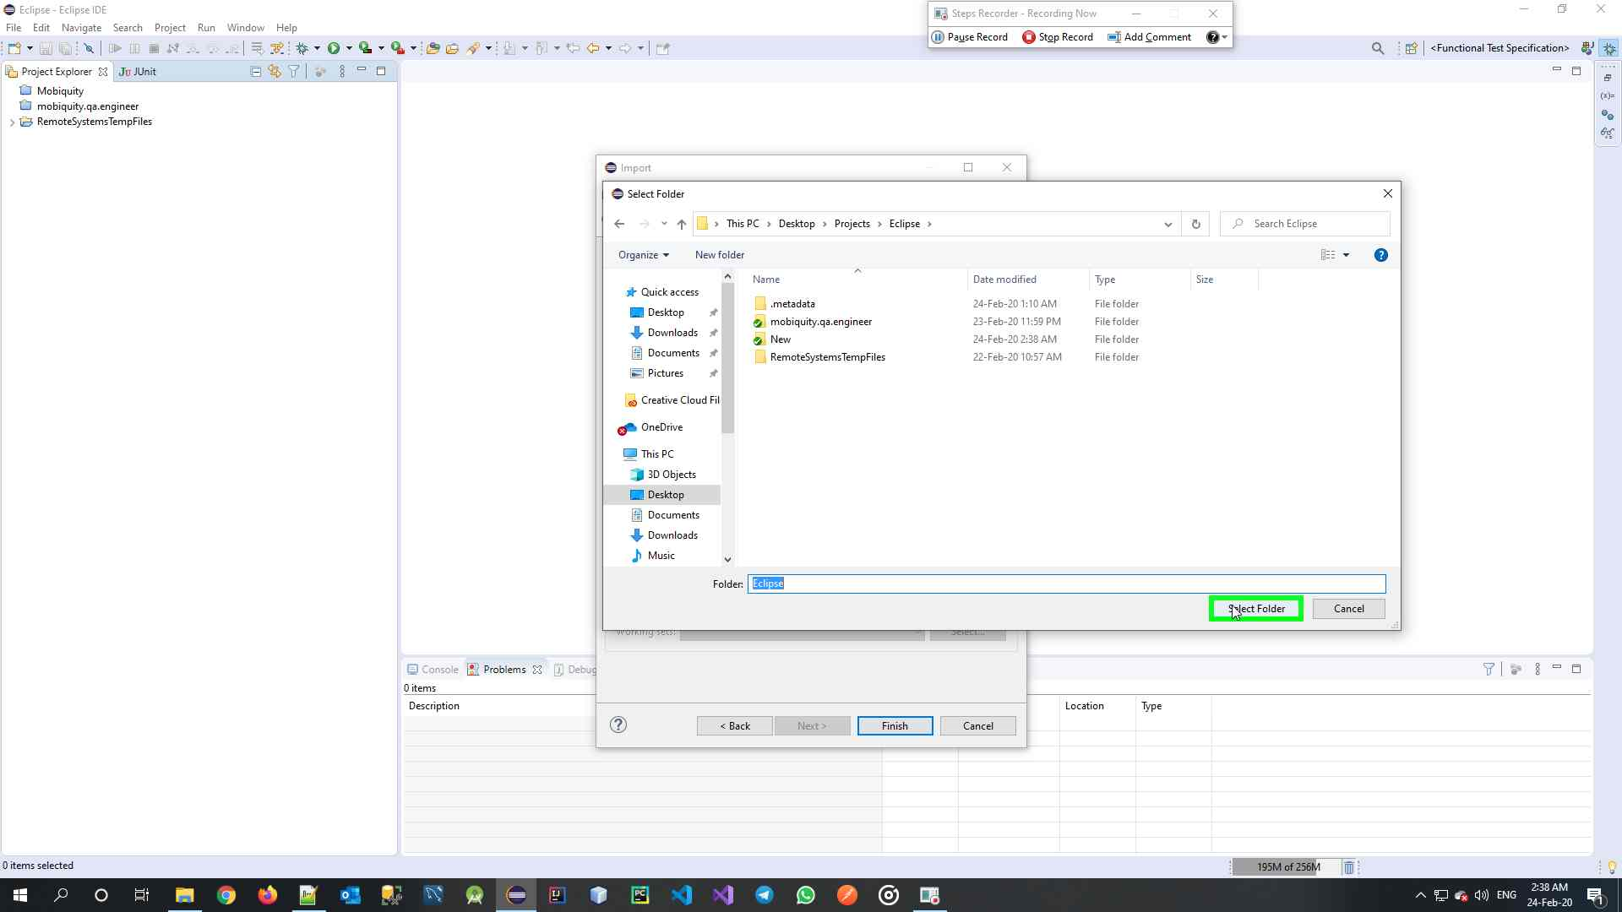

Select the Parent Folder of the one created (in my case it’s my workspace), then click Select Folder

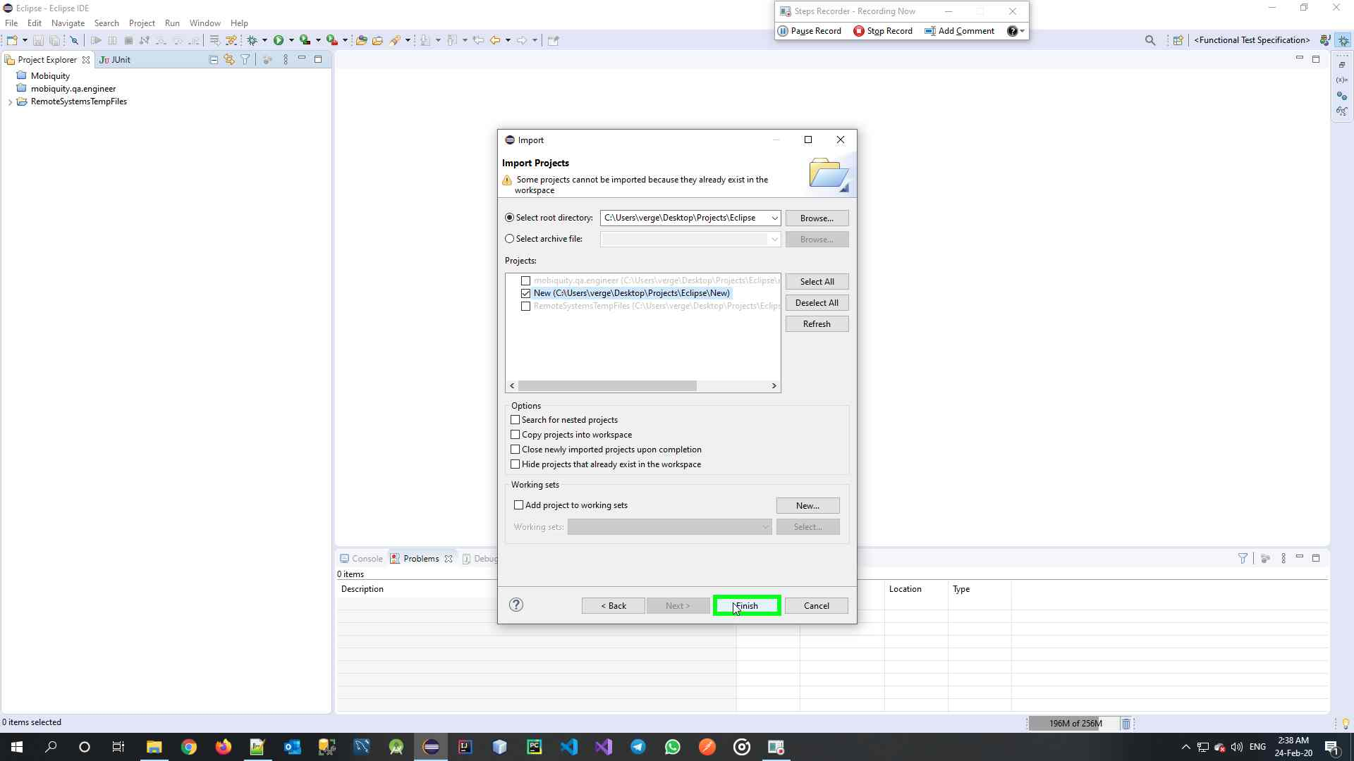

Select the Project Folder (Same name as created folder)

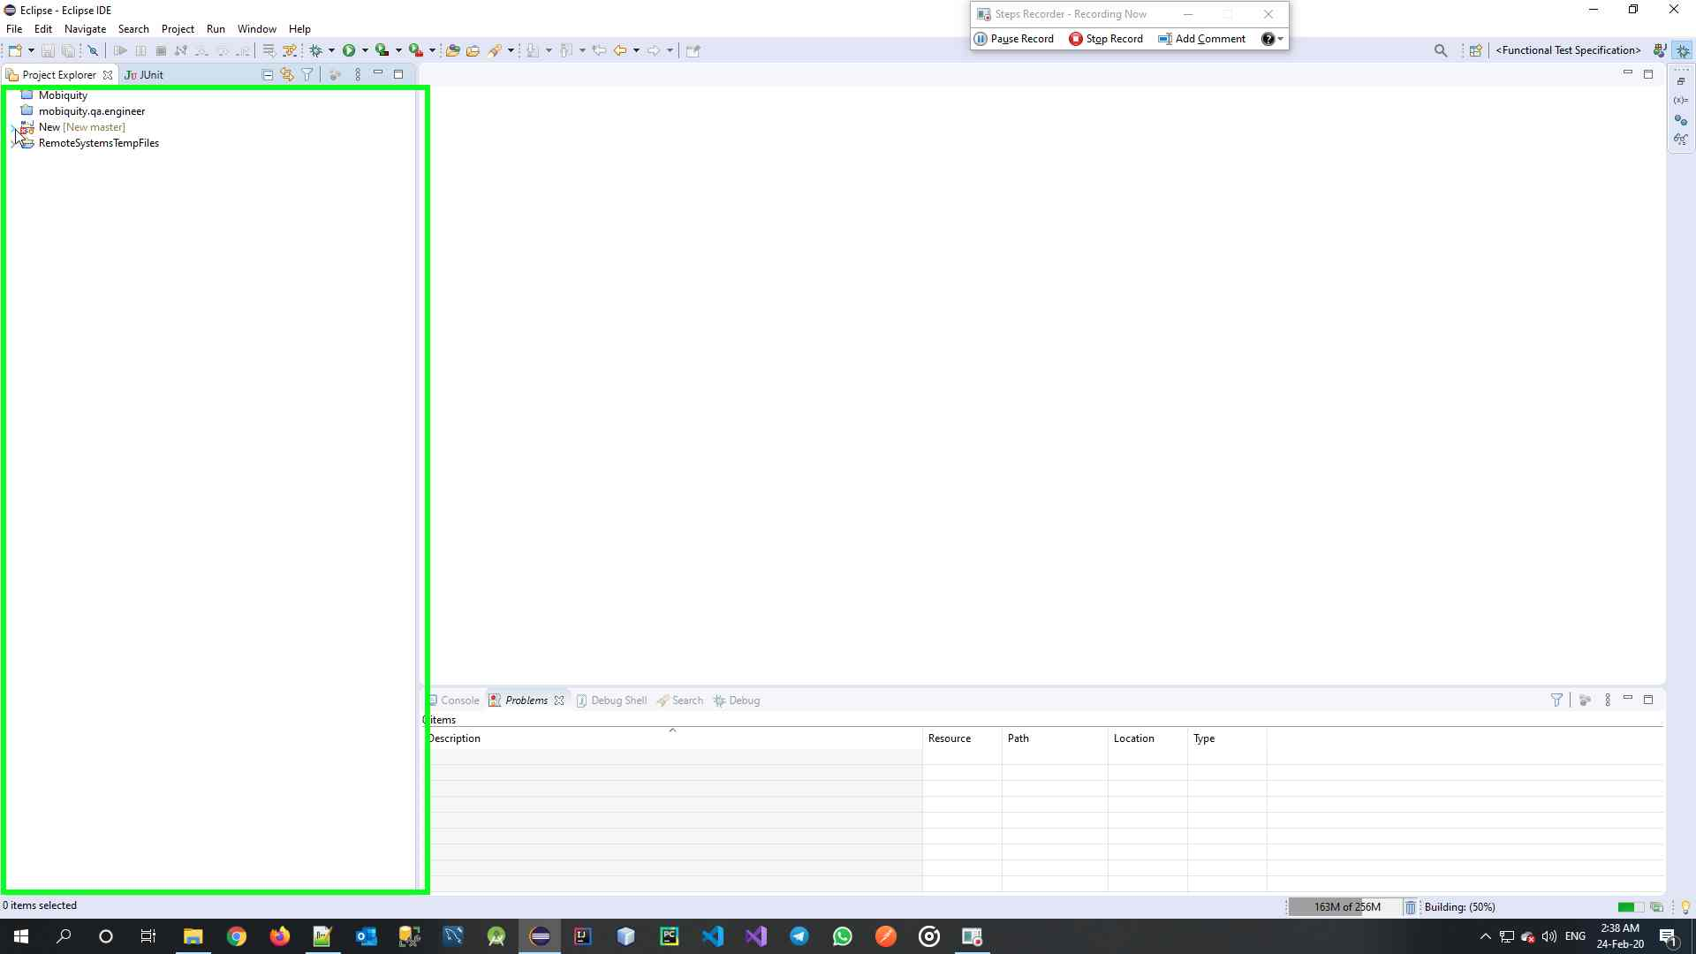

Verify project it’s loaded

1. Then Run the Main class with the Main1 Profile (if profile doesn’t exists, create a new one)

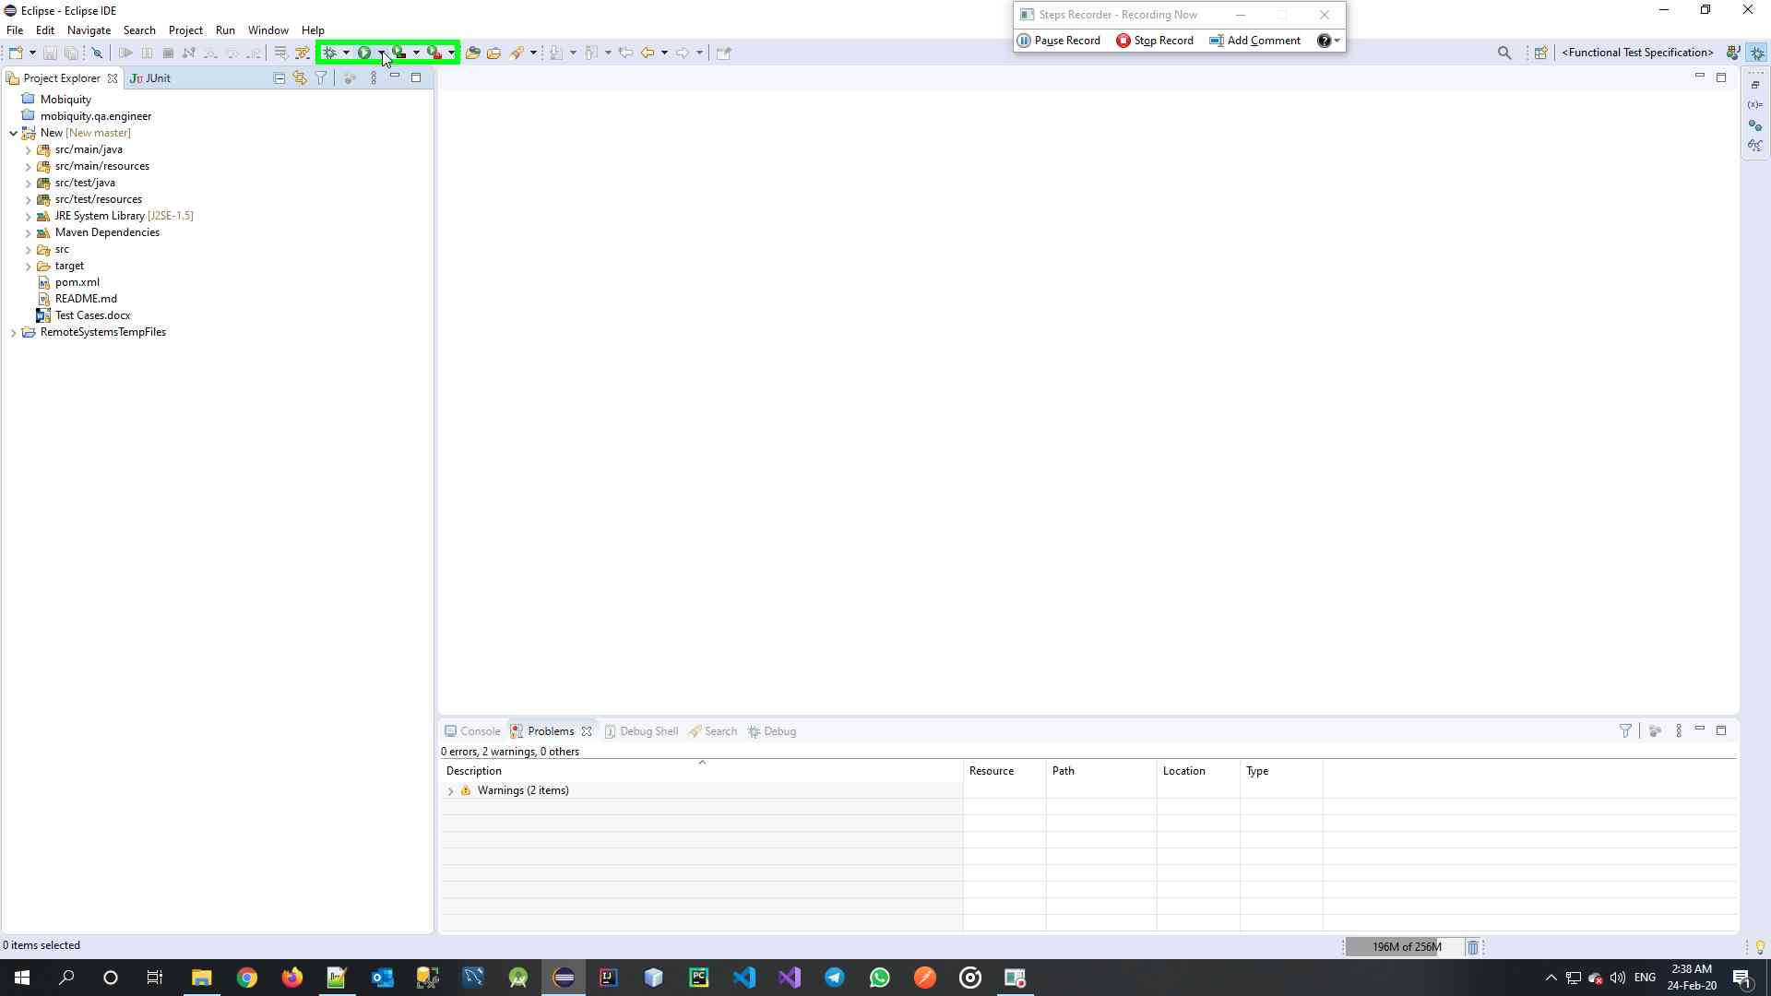Click on the arrow at the right of the Run Button

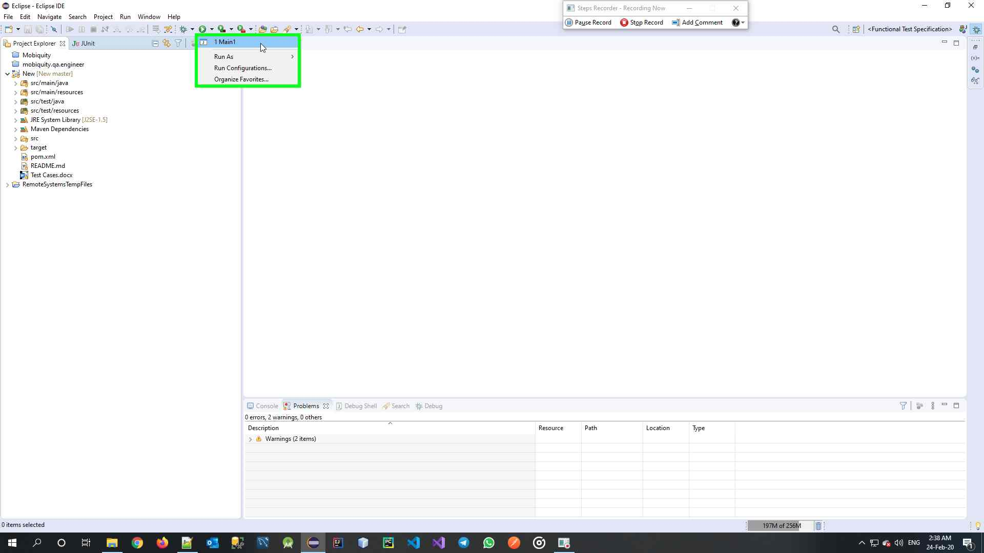Click on the Profile named Main1

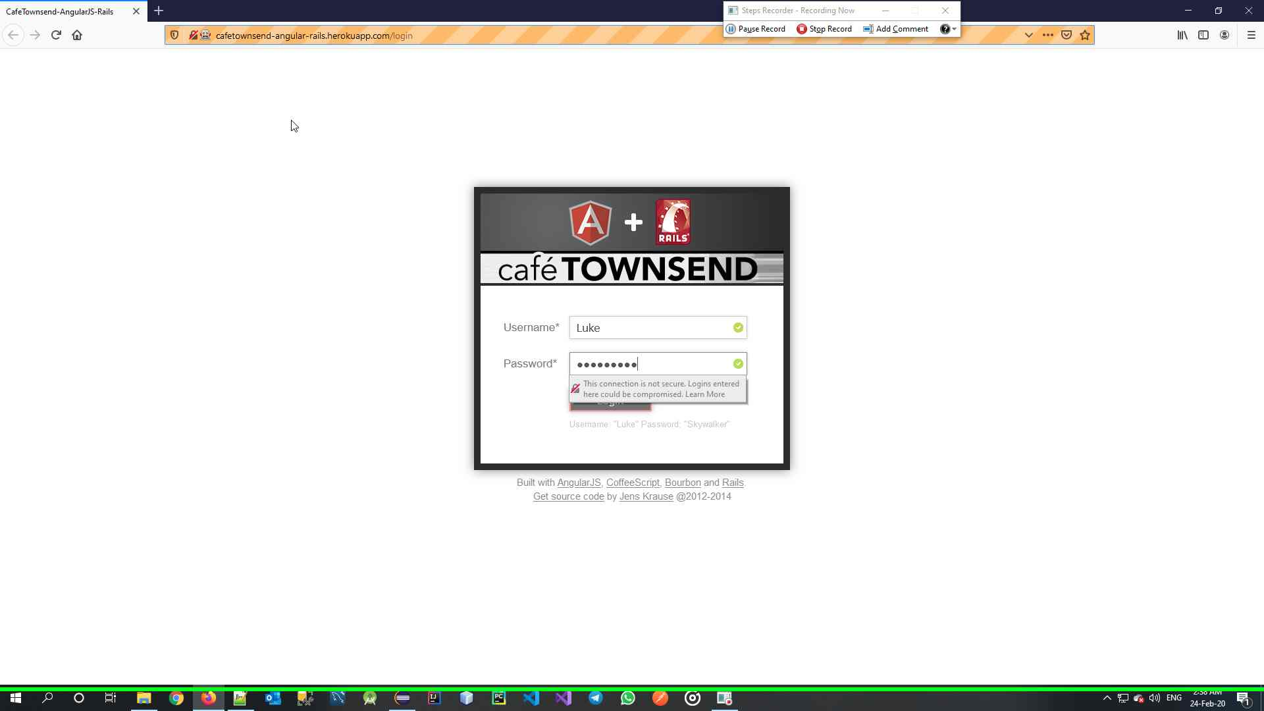

Verify Tests are Executed

1. Run Profile Creation

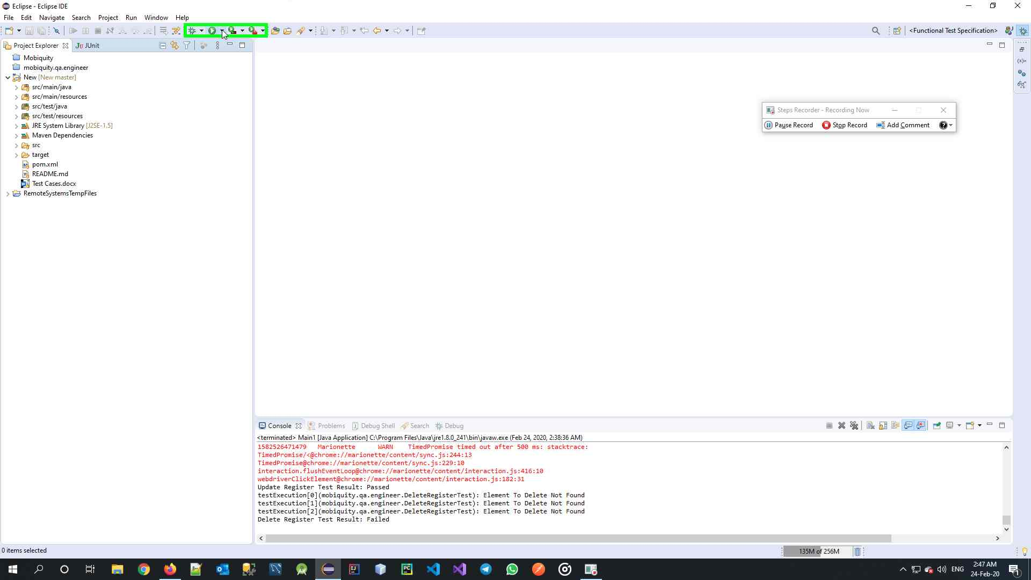

Click on the Arrow at the right of the Run Button

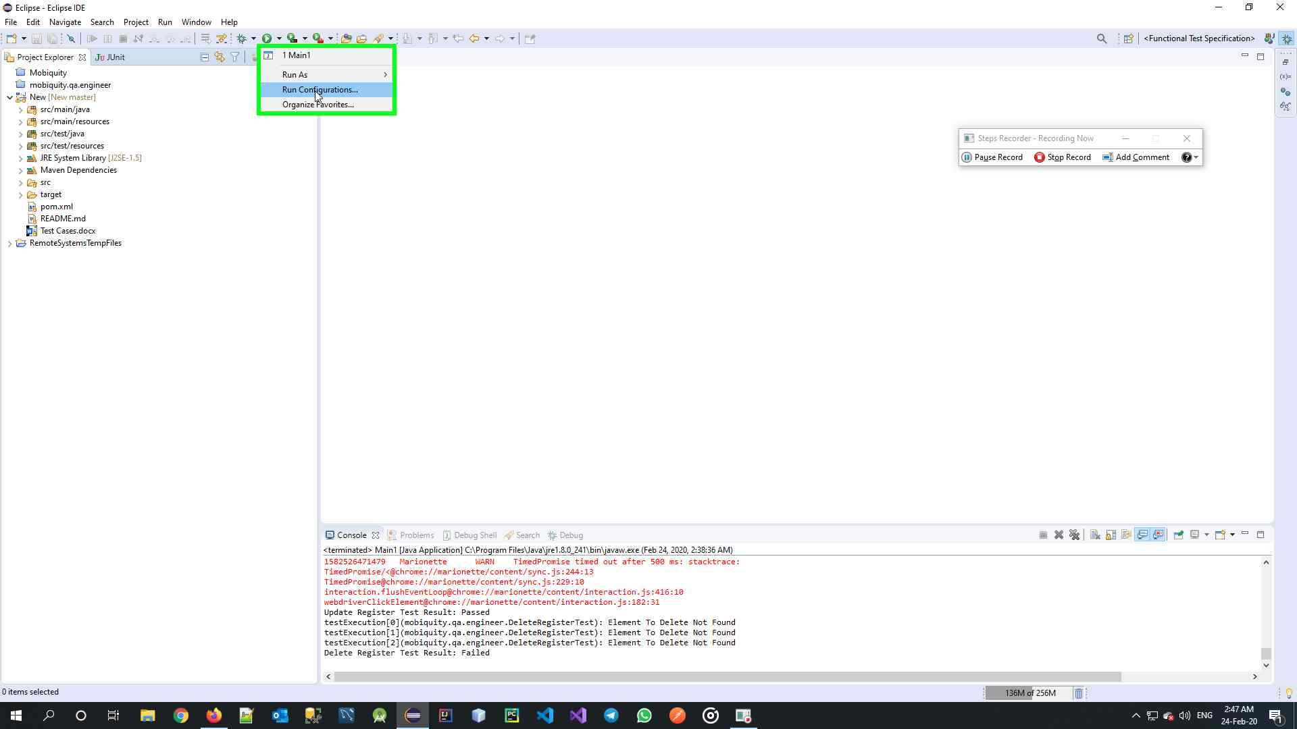

Click on Run Configurations

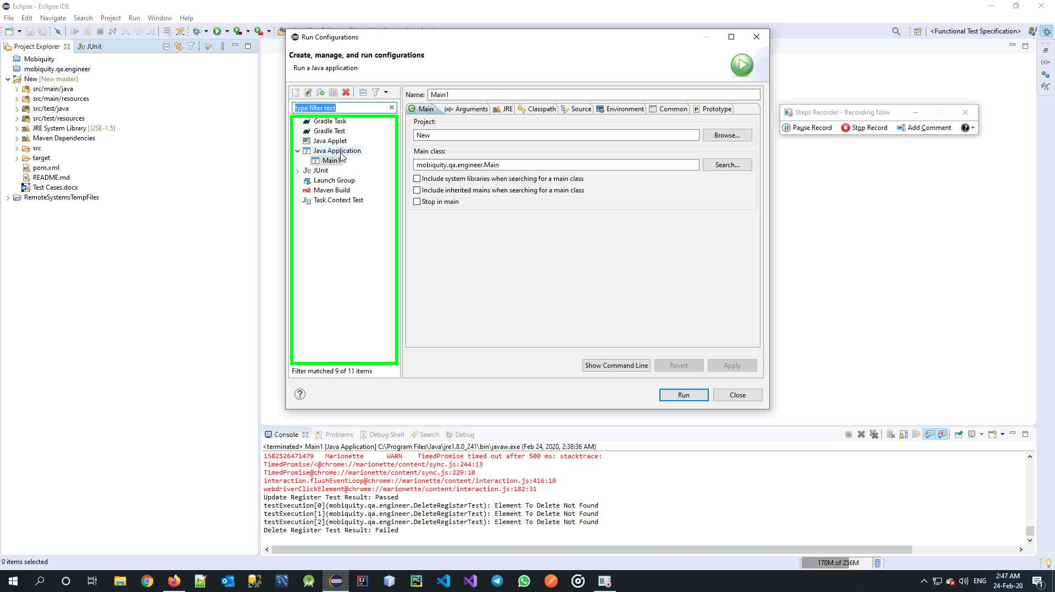

Click on Java Application

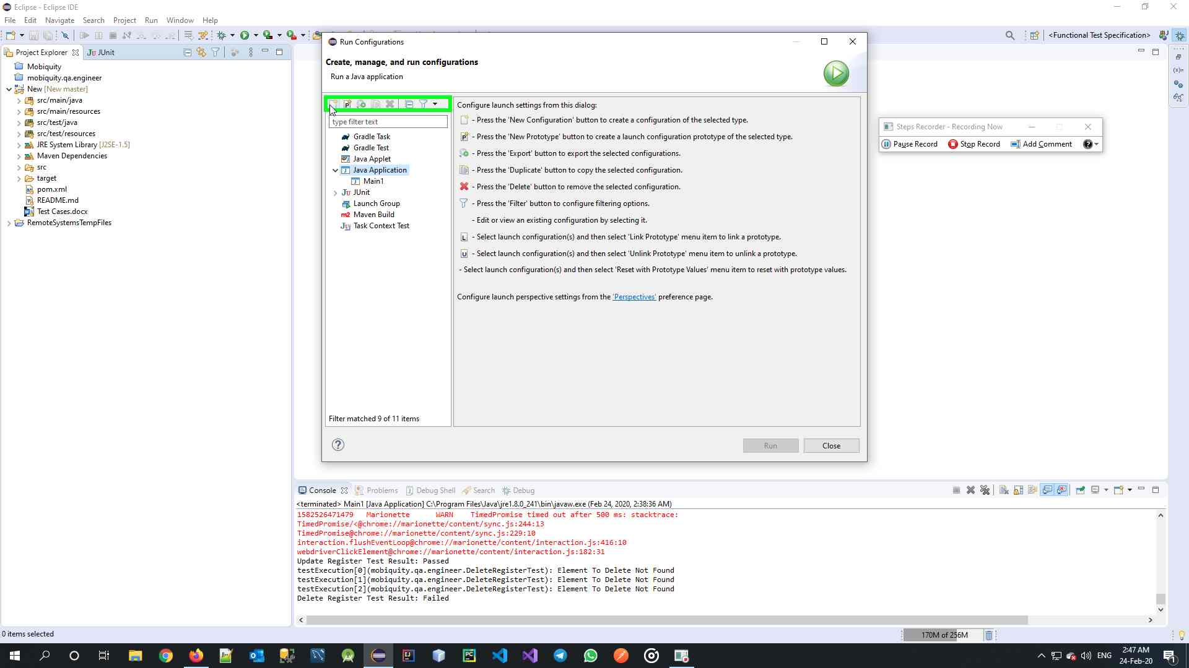

Click on New Button

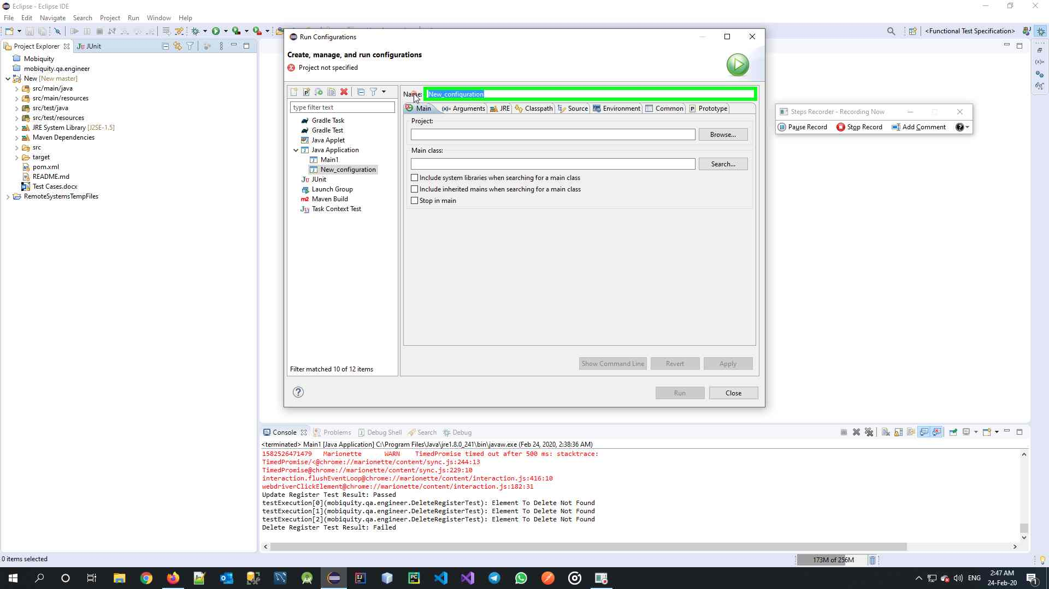

Set a Profile Name

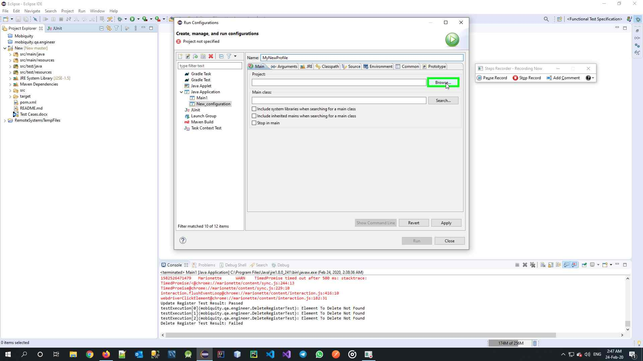

Click Browse on the Project

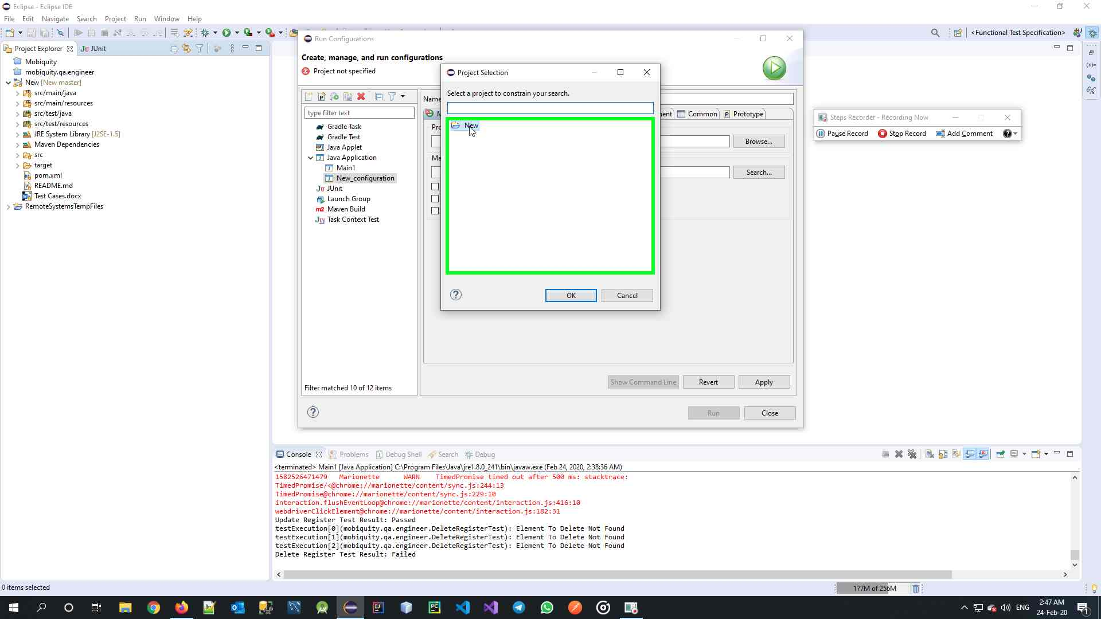

Select the Project

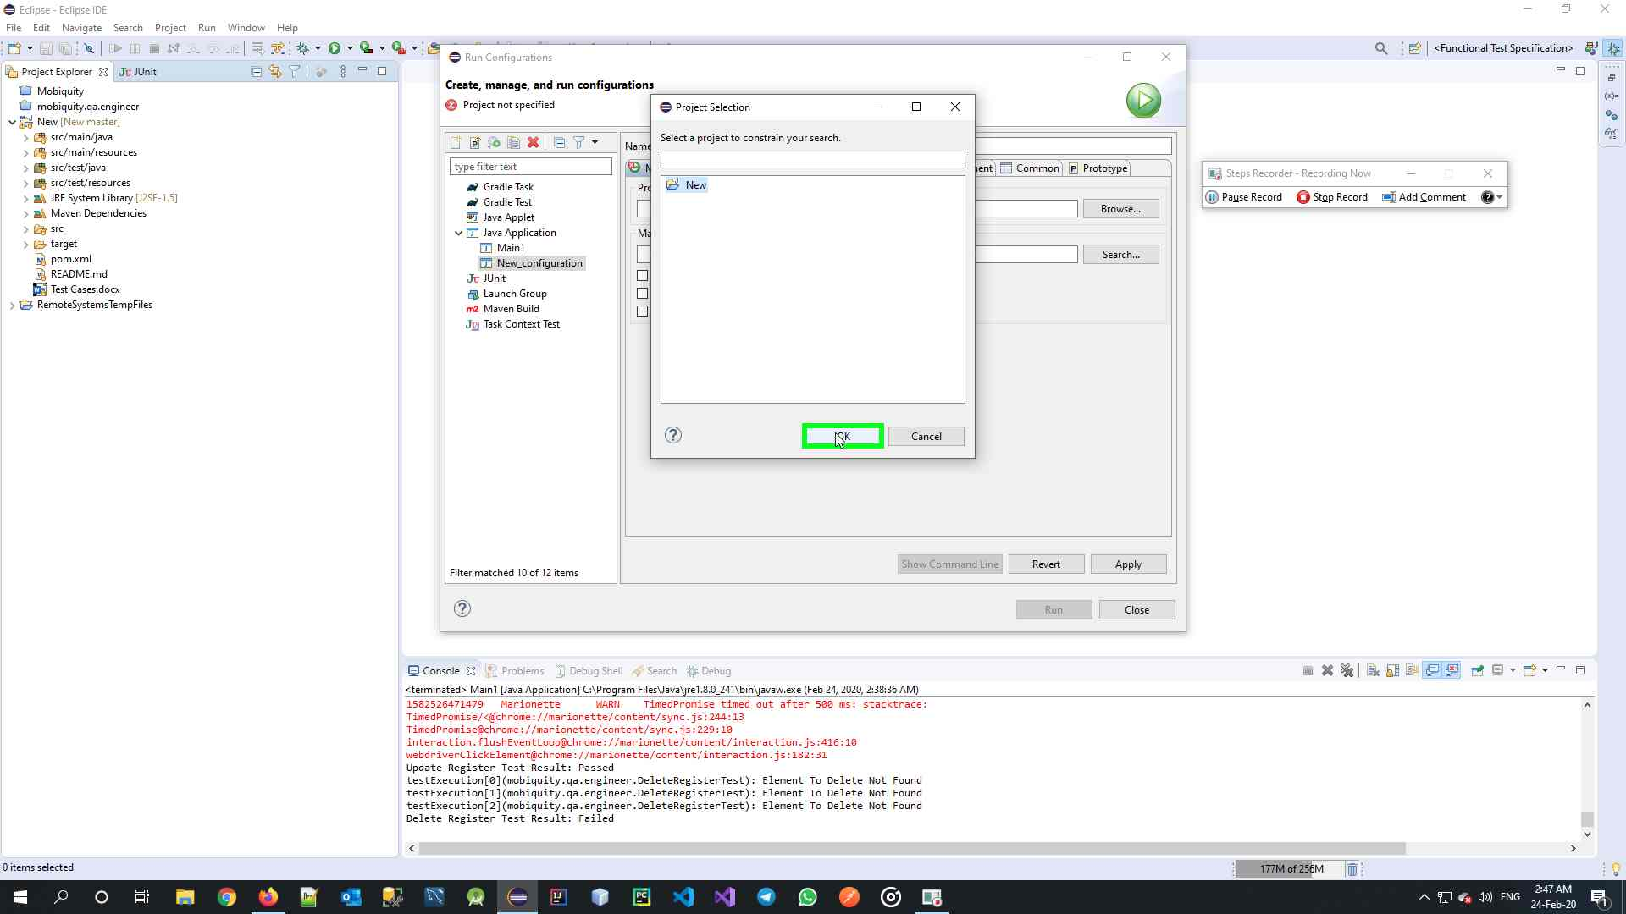

Click OK

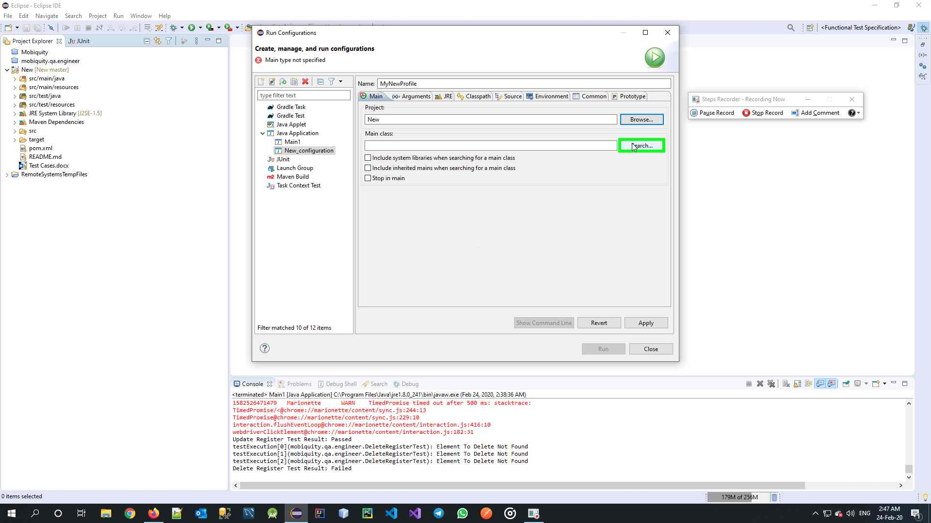

Click on Browse on Main Class

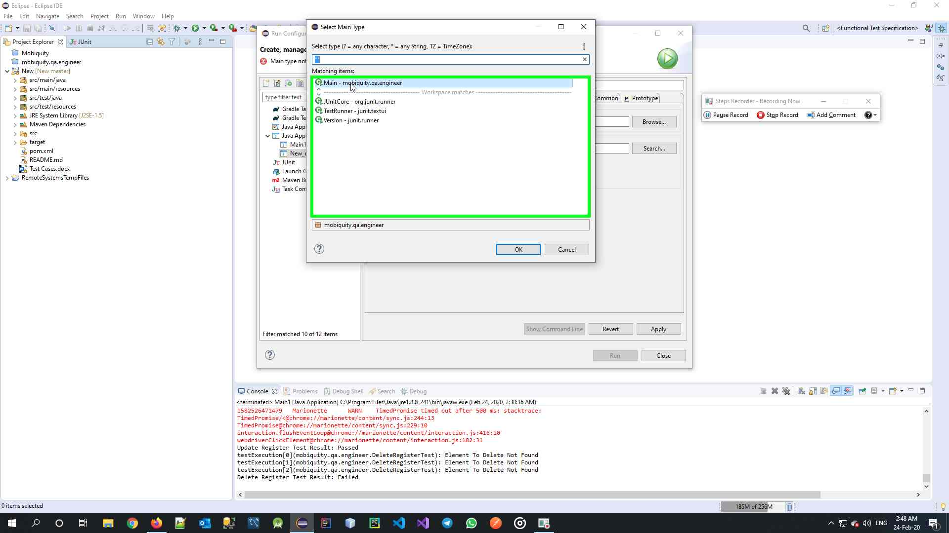

Select the Main class under Package “mobiquity.qa.engineer”

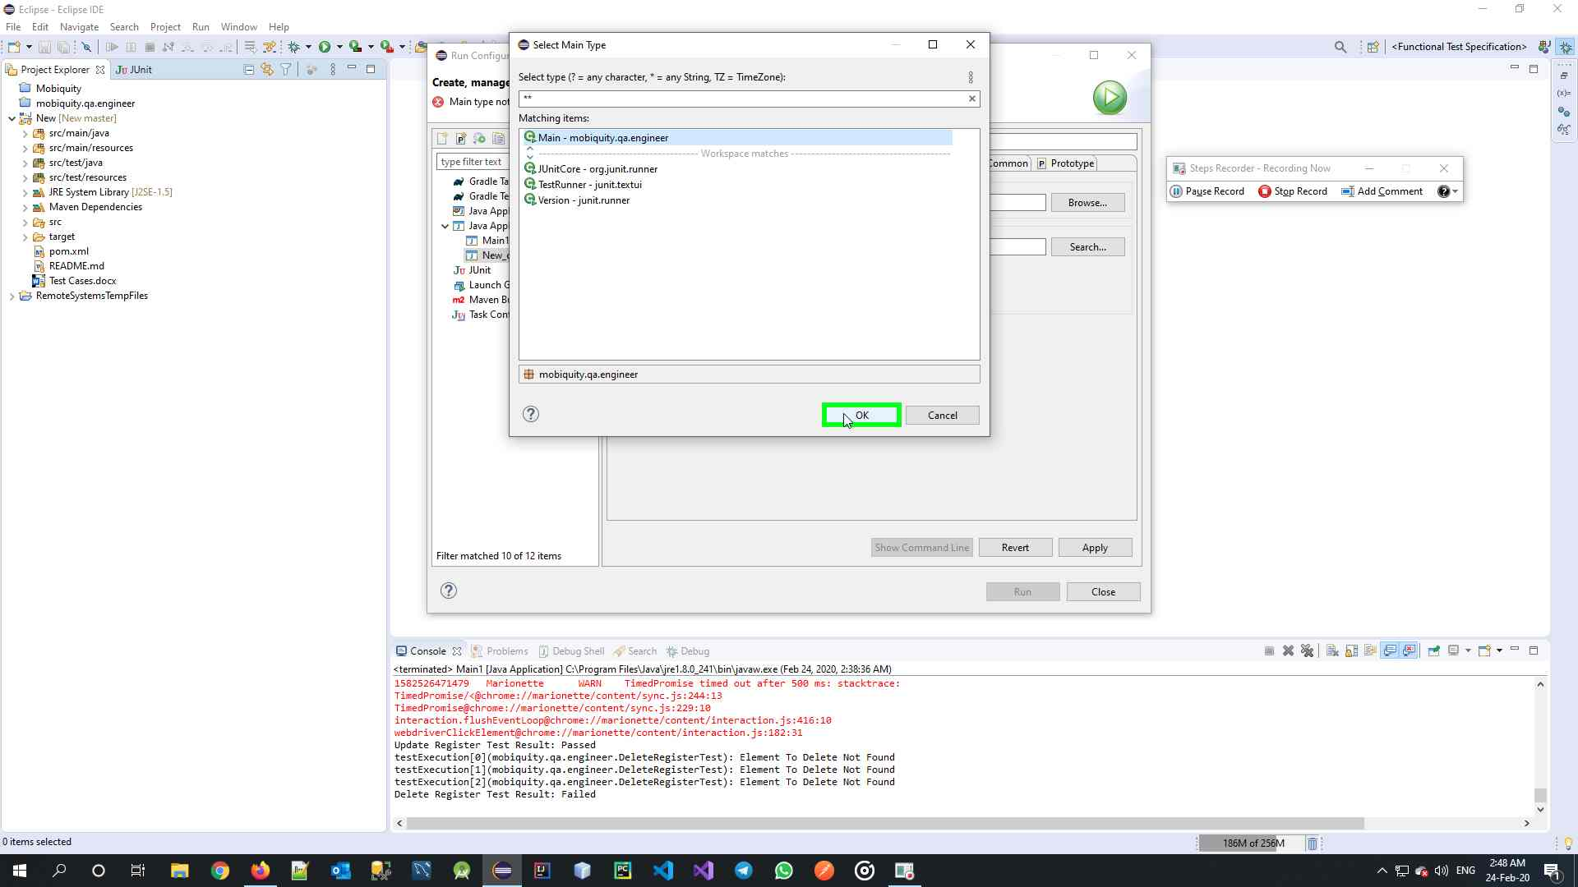

Click OK

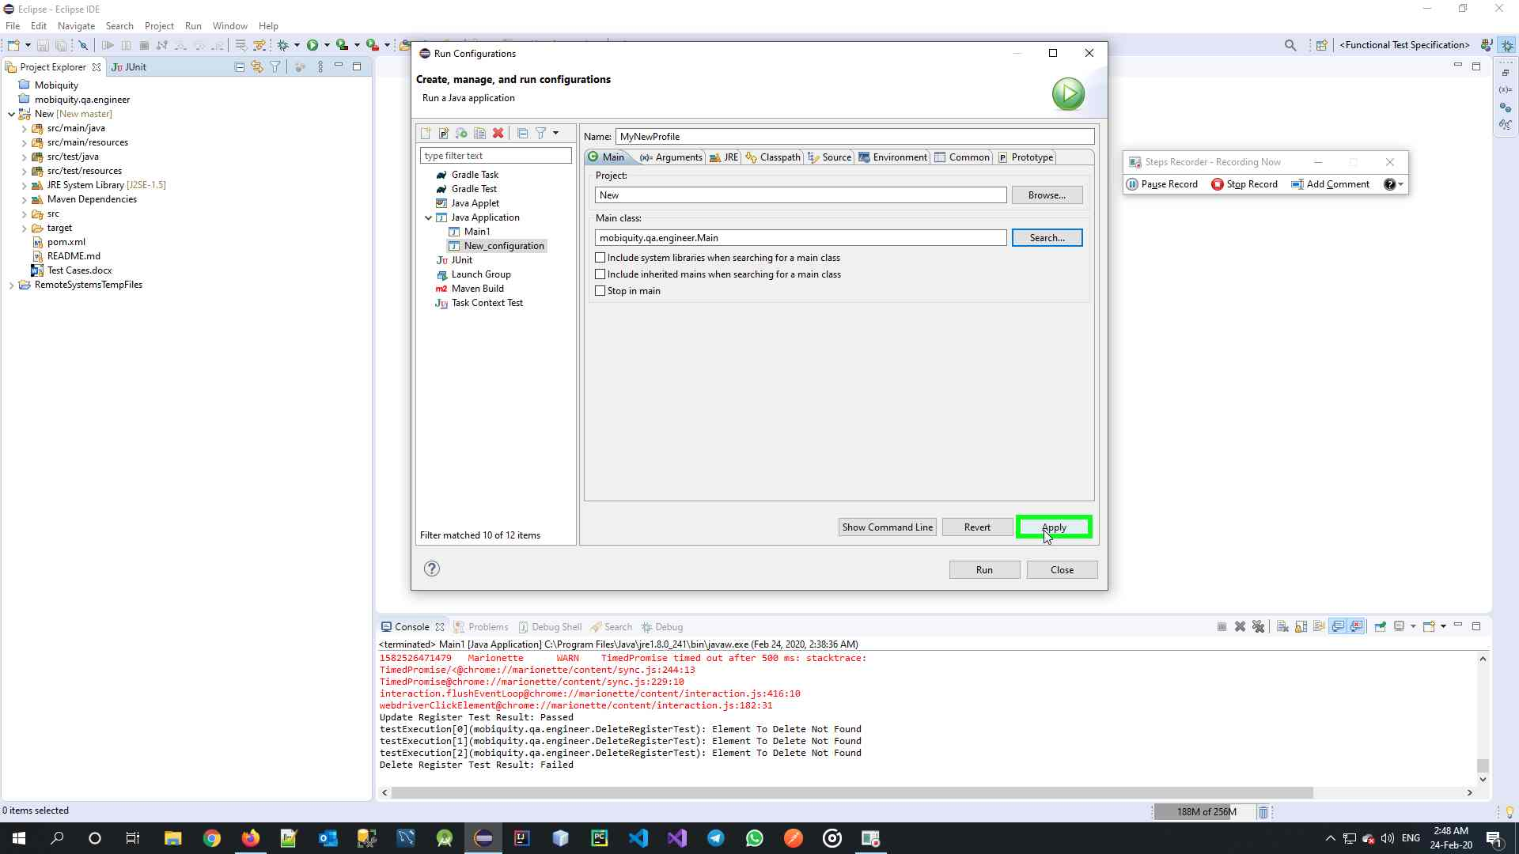

Click Apply

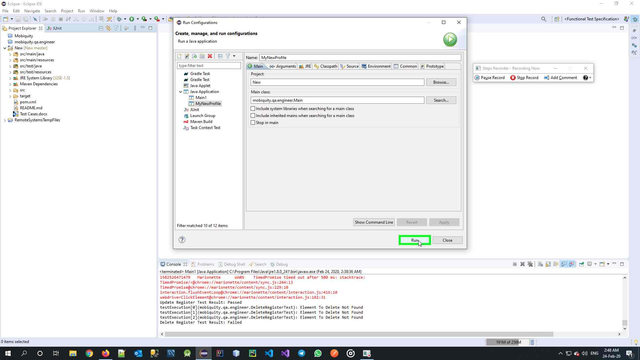

Click Run

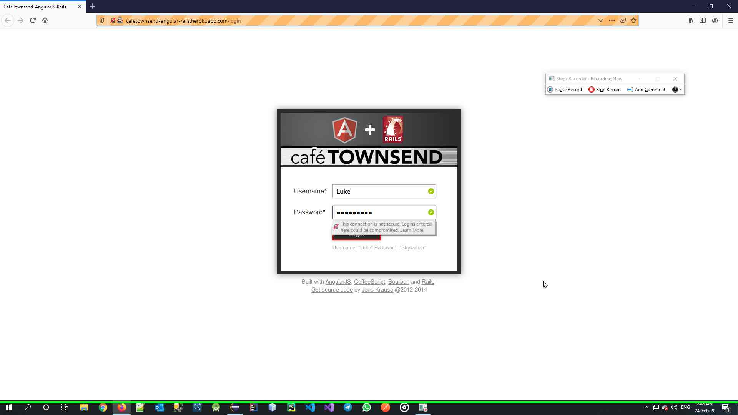

Verify Test Execution is Started

**NOTE:** If you’re running on MacOSX or Linux, you should give WebDriver rights to Execute with chmod. WebDrivers are located under “/src/test/resources/webdriver/chrome” and “/src/test/resources/webdriver/firefox” respectively, and are named as “linux”, “mac”, “windows.exe” in order to Auto-Select based on the Operating System.